**Decision Tree**

The name saying Tree , It is a kind of Tree structure

In tree ==== > leaf branches roots

How will split the data, to split the data will take a help of a variable

That variable is called Root node

Which variable becomes a root node

You want to make one person as leader =====

A guy has more random ness =========== not become good leader

A guy has less random ness more focus ==== good leader

Random ness

Shannon information criteria

Concept name= Entropy

Ramesh and kumar best friends

Ramesh has a family function in two days , for that function

Both Ramesh and kumar are working together

So naturally one day Ramesh called to kumar ===== kumar ?

Kumar know why Ramesh called ====== > less random ness ===== information already know

One day suddenly 1am kumar has some missed call about rames

Kumar ===== more random ness ===== information you does not know

Ind vs zim =========== > ind

Ind vs aus ========= >

Value of the information ===== random ness ======== entropy

1. You does not know about information
2. You have more random ness
3. Entropy is more

$$Entropy:$$

$$entropy(H)=-\sum_{i}^{n}{}p_{i}*p_{i}$$

$$information in form of bits, base=2$$

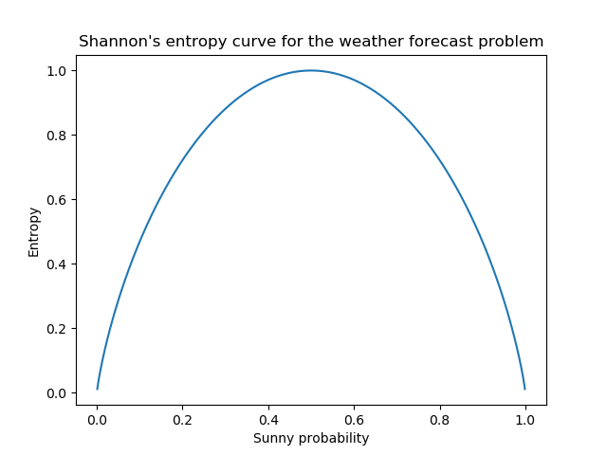

$root node has less random ness===less entropy$

$$Toss a coin:will give either head or tail$$

$$p\left(h\right)=0.5 , p\left(t\right)=0.5$$

$$entropy(H)=-\sum_{i}^{n=2}{}p_{i}*p_{i}$$

$${H=-p}_{1}*p_{1} -p_{2}*p_{2}$$

$${H=-p}_{h}*p_{h} -p_{t}*p_{t}$$

$$H=-0.5*0.5 -0.5*0.5 = -k-k=-2k$$

$$H=-2*0.5*0.5$$

$$H=-0.5$$

$$H=-\frac{1}{2} \frac{1}{a}=a^{-1}$$

$$H=-2^{-1 } loglog a^{m}=mloga$$

$$H=-\left(-1\right)2 loga^{a}=1$$

$$H=1 hence proved$$

$$How to find the root node:$$

|  |  |  |
| --- | --- | --- |
| Id | Age | Buys a computer |
| 1 | Y | N |
| 2 | Y | N |
| 3 | MA | Y |
| 4 | S | Y |
| 5 | S | Y |
| 6 | S | N |
| 7 | MA | Y |
| 8 | Y | N |
| 9 | Y | Y |
| 10 | S | Y |
| 11 | Y | Y |
| 12 | MA | Y |
| 13 | MA | Y |
| 14 | S | N |

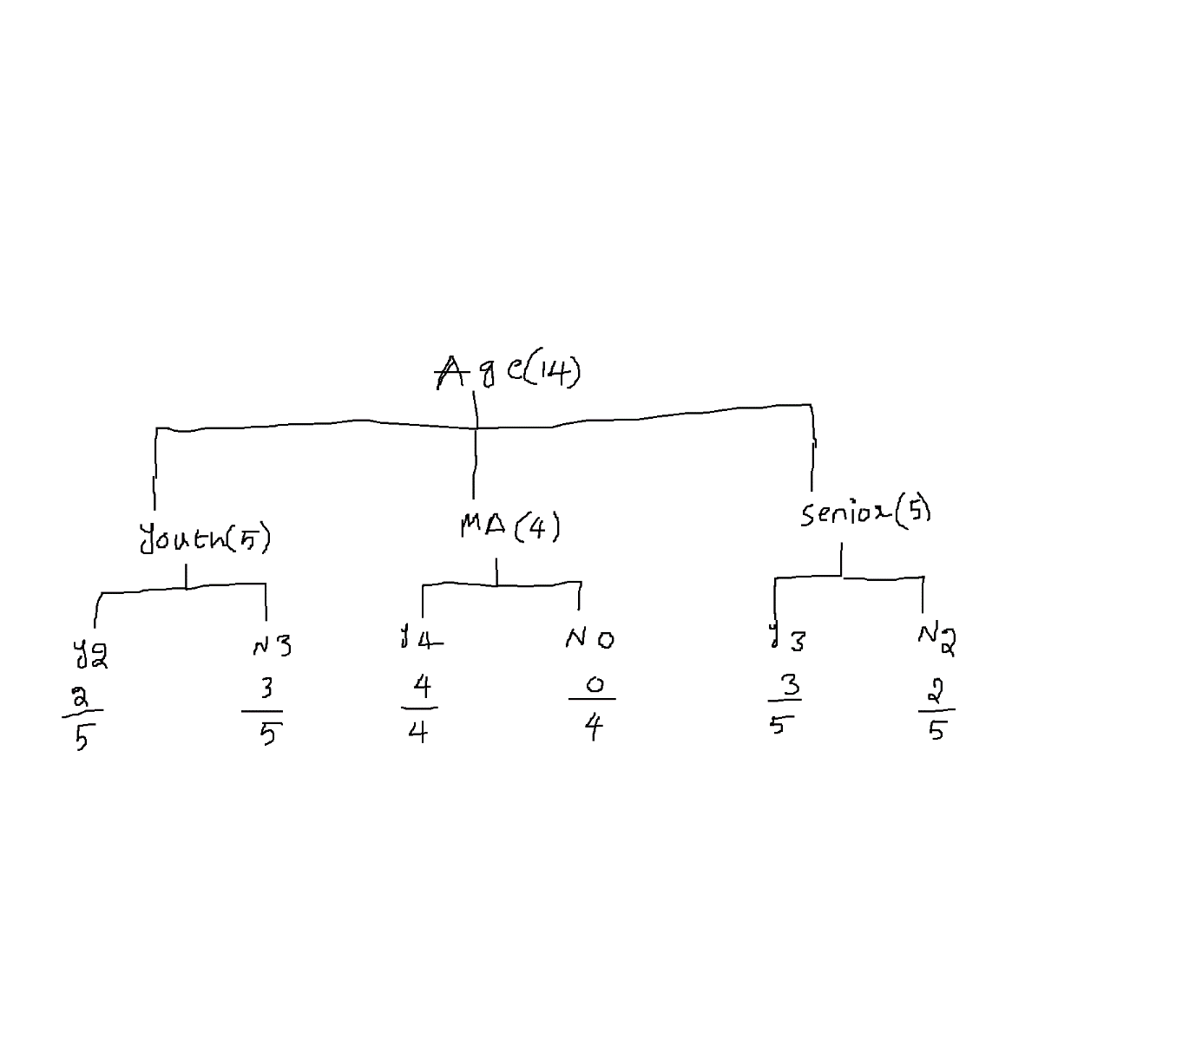

$$H\left(Age\right)=H\left(Youth\right)+H\left(MA\right)+H(Senior)$$

$$H\left(Youth\right)={-p}_{yes}*p_{yes} -p_{no}*p_{no}$$

$$-\frac{2}{5}*\frac{2}{5} -\frac{3}{5}*\frac{3}{5}$$

$$H\left(MA\right)=-\frac{4}{4}*\frac{4}{4} -\frac{0}{4}*\frac{0}{4}$$

$$H\left(Senior\right)=-\frac{3}{5}*\frac{3}{5} -\frac{2}{5}*\frac{2}{5}$$

$$H\left(Age\right)=w_{youth}*H\left(Youth\right)+w_{MA}*H\left(MA\right)+w_{senior}*H(Senior)$$

$$w_{youth}=\frac{5}{14};w_{MA}=\frac{4}{14};w_{senior}=\frac{5}{14}$$

$$H\left(Age\right)=\frac{5}{14}*H\left(Youth\right)+\frac{4}{14}*H\left(MA\right)+\frac{5}{14}*H(Senior)$$

$$H\left(Age\right)=$$

$\frac{5}{14}*\left[-\frac{2}{5}*\frac{2}{5} -\frac{3}{5}*\frac{3}{5} \right]+$

$\frac{4}{14}*\left[-\frac{4}{4}*\frac{4}{4} -\frac{0}{4}*\frac{0}{4} \right]+ \frac{5}{14}*\left[-\frac{3}{5}*\frac{3}{5} -\frac{2}{5}*\frac{2}{5} \right]$

$$step-2:Total entropy$$

$$no.of yes=9, no.of no=5$$

$$p\left(yes\right)=\frac{9}{14};p\left(no\right)=\frac{5}{14}$$

$$H={-p}_{yes}*p_{yes} -p_{no}*p_{no}$$

$$H=-\frac{9}{14}*\frac{9}{14} -\frac{5}{14}*\frac{5}{14}$$

$$step-3:will calculate individual entropy H\left(income\right);H\left(student\right);H(Credit_{rating})$$

$$age;income;student;CR=====out of this one variable become a root node$$

$$Information gain(Variables):H\left(T\right)-H(varaible)$$

$$Information gain\left(age\right)=H\left(Total\right)-H(Age)$$

$$Information gain\left(income\right)=H\left(Total\right)-H(income)$$

$$Information gain\left(student\right)=H\left(Total\right)-H(student)$$

$$Information gain\left(CR\right)=H\left(Total\right)-H(CR)$$

$$less entropy gives less random that is important root node$$

$$less entropy means more information gain$$

$$which variable has more information gain, that become a root node$$

$$step-1: calculate all individual variable entropy$$

$$step-2:calculate total entropy based on overall lables$$

$$step-3:calculate information gain$$

$$conclusion:which have more information gain root node$$

$$H\left(Total\right)=0.940$$

$$H\left(age\right)=0.694$$

$$Information gain\left(age\right)=0.246$$

$$Information gain\left(income\right)=0.029$$

$$Information gain\left(student\right)=0.151$$

$$Information gain\left(CR\right)=0.048$$

$$Information gain\left(age\right)=0.246 root node$$

$$entropy of ID column:$$

$$H\left(ID\right)=w_{1}*H\left(1\right)+w_{2}*H\left(2\right)+….+w_{14}*H(14)$$

$$w_{1}=w_{2}=w_{3}=…=w_{14}=\frac{1}{14}$$

$$-1*1$$

$$H\left(1\right)=H\left(2\right)=…=H\left(14\right)=-1*1$$

$$H\left(ID\right)=\frac{1}{14}[H\left(1\right)+H\left(2\right)+….+H\left(14\right)]$$

$$H\left(ID\right)=\frac{1}{14}[-1*1 -1*1 +….-1*1 ]$$

$$H\left(ID\right)=\frac{-1}{14}*14*1$$

$$H\left(ID\right)=1=approximatly=0$$

$$gain\left(ID\right)=H\left(Total\right)-H\left(Id\right)=== >maximum$$

$$root node is id, Id is root node pattern learning$$

$$why will remove the ID$$

$$Step-4:Split information ratio$$

$$gain ratio=\frac{Gain}{split information }$$

$$split information will provide how that particular variable is splitted$$

$$age is divide into three parts youth=5 p\left(youth\right)=\frac{5}{14}$$

$$MA=4 p\left(MA\right)=\frac{4}{14}$$

$$senior=5 p\left(senior\right)=\frac{5}{14}$$

$$split information=-\frac{5}{14}*loglog \left(\frac{5}{14}\right) -\frac{4}{14}*loglog \left(\frac{4}{14}\right) -\frac{5}{14}*log⁡(\frac{5}{14})$$

$$Step-1:Calculate individual variable entropy$$

$$Step-2:Calculate total entropy$$

$$Step-3:Calculate gain=H\left(T\right)-H\left(Variable\right)$$

$$Step-4:Calculate gain ratio=\frac{Gain}{split information}=\frac{step3}{split information}$$

$$Step-1:Calculate individual variable entropy$$

$$Step-2:Calculate total entropy$$

$$Step-3:Calculate gain=H\left(T\right)-H\left(Variable\right)=========ID3$$

**(Iterative Dichotomiser)**

$$Step-4: C4.5$$

$$CART:Classification and Regreesion Technqiue$$

$$maths: Gini index$$

$$entropy talks abour random ness$$

$$Gini impurity of the attribute$$

$$Gini=1-\sum_{i=1}^{n}{}p_{i}^{2}$$

$$Gini=1-\sum_{i=1}^{n}{}p_{i}^{2}=1-[p_{1}^{2}+p_{2}^{2}]$$

$$Gini=1-\sum_{i=1}^{n}{}p_{i}^{2}=1-[p_{yes}^{2}+p_{no}^{2}]$$

$$Gini calculations every time consider two parts at a time$$

$$income is divided into three parts High;Mediaum;Low$$

$$\left\{\right\},\left\{High\right\};\left\{Mediaum\right\};\left\{Low\right\};\left\{High,Medium\right\},\left\{Medium,low\right\},\left\{High;low\right\},\{High,Medium,low\}$$

$$\left\{High,Medium,low\right\}=power set$$

$$\left\{High,Medium\right\},\left\{Medium,low\right\},\left\{High;low\right\}$$

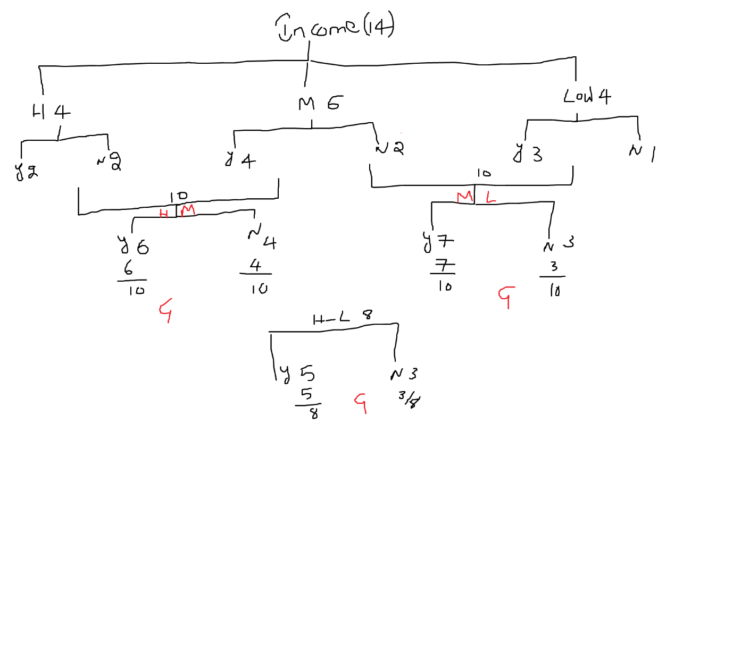

$$Gini=w_{lm}*Gini_{low-med}+w_{h}*Gin_{high}$$

$$w_{lm}=\frac{10}{14};w_{h}=\frac{4}{14}$$

$$Gini\left\{Medium,low\right\}=1-\sum_{i=1}^{n}{}p_{i}^{2}=1-[p_{yes}^{2}+p_{no}^{2}]$$

$$Gini\left\{Medium,low\right\}=1-[{\left(\frac{7}{10}\right)}^{2}+{\left(\frac{3}{10}\right)}^{2}]$$

$$Gini\left\{high\right\}=1-[{\left(\frac{2}{4}\right)}^{2}+{\left(\frac{2}{4}\right)}^{2}]$$

$$Gini_{lm_vs_h}=\frac{10}{14}*1-[{\left(\frac{7}{10}\right)}^{2}+{\left(\frac{3}{10}\right)}^{2}]+\frac{4}{14}*1-[{\left(\frac{2}{4}\right)}^{2}+{\left(\frac{2}{4}\right)}^{2}]$$

$$parameters vs hyper parameters$$

$$parameters are constrains change by algorithm itself$$

$$No manual intervetion$$

$$for example in Linear regression b_{1} and b_{2} coeff are developed by algorithm itself$$

$$this is called parameters$$

$$To find the parameters there many methods are there$$

$$ols,mle,gradient descent in that which method you are choose that is depend on user choice$$

$$that is called hyper paramerters$$

$$parameters: define by algorithm$$

$$hyper parameters:define by user$$

$$in Decision Tree: to find the root node$$

$$1) Entropy 2) Gini =====hyper parameters$$